WORKSHEET FOR PORTER’S FIVE FORCE MODEL

1. Select a company that produces and markets sports and leisure clothing. Use Porter’s model to help understand forces in your environment and to help understand the potential return (if any) on a new product or service.

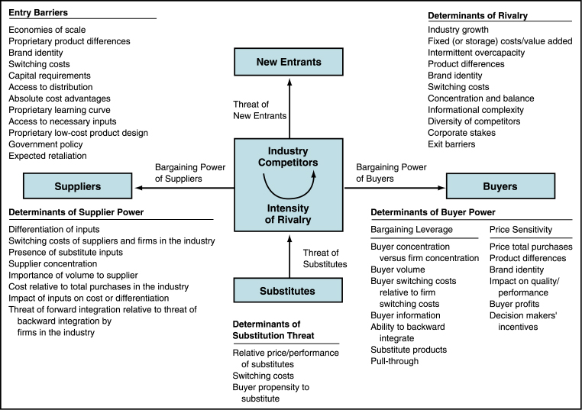

Threat of entry of new competitors:

Bargaining power of suppliers:

Threat of substitute products or services:

Bargaining power of customers:

Rivalry among existing firms in the industry:

