**Project – Based Learning (PBL)**

**Template**

Project-Based Learning is a teaching method in which students gain knowledge and skills by working for an extended period of time to investigate and respond to an engaging and complex question, problem or challenge

**PBL code name: C5_S2_5**

**PBL title: Clean water project**

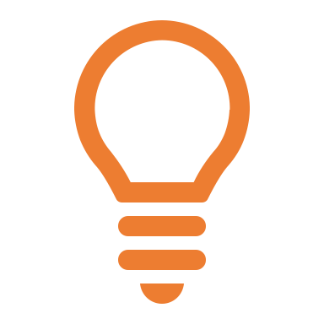

**Project Idea**

In Africa, one of the driest places on earth, water is scarce resource. A technology company is therefore proposing to install devices that can produce water from air through condensation. All that is needed is electricity – plug it in and it works. Advanced devices are projected to produce up to 4000 liters per day. According to the UN, the average person in the world needs 20 to 50 liters of water per day for drinking, cooking and sanitary purposes. Currently, there are estimations that around 300 million people in Africa do not have access to clean water. Keep in mind that electricity is also scarce in Africa, and many rural areas where the water is needed most are not connected to any electricity grid. Create a Flipchart where you will list all aspects needed to describe how rural areas in Africa could be supplied with water from the air and how the whole project could be achieved and rolled out. It is up to you to decide how you 🡪 **Evaluate the idea**



**Driving Question(s)**

1. Who’s help will you need to achieve the aim of this project?
2. What are obstacles in achieving the aim of the project?
3. Who is going to pay for the devices?
4. Think about ROI, will the machine pay off for villagers if they have to finance parts or even all of it by themselves?
5. If someone finances it for them, who could that be?
6. What other factors influence the outcome e.g. bad air quality, rebel groups, corrupt governments…
7. Do you think it’s feasible?

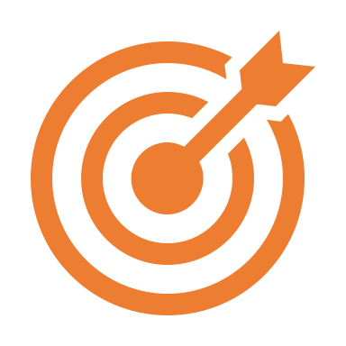

**Objectives**

* *Create a Flipchart where you list all aspects that are in your opinion necessary to complete this project.*
* *Evaluate this idea – you decide how to do it*

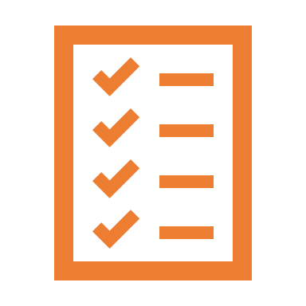

**Tasks**

* *Develop a solution on how this project could be rolled out in regions of Africa that do not have access to clean drinking water. Remember that the Benefits must be bigger than the costs!*

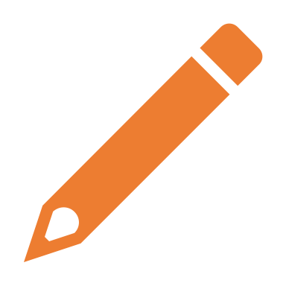

**Notes**

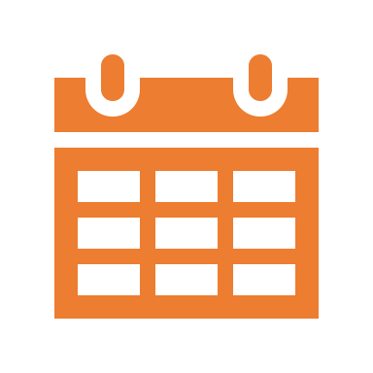

**Project Plan**